List the various functions of DBMS with query and example.

**4 CO1**

Q 2 Differentiate DROP and TRUNCATE commands of SQL with suitable example.

**4 CO2**

Q 3 List the various SET operators used in SQL with its functionality.

**4 CO3**

Explain the three level architecture of DBMS with the diagram.

**10 CO1**

Q 8 Discuss on the purpose of GROUP BY and HAVING clause in SQL with suitable

example. **10 CO3**

Consider the table Product (pid, pname, price, category, manufacturer) and give the

query to generate the below given reports

a. Product name who have maximum price

b. Product name who have minimum price

c. The average price of all products

d. The number of products in the company

e. Specify the various catogory in the company

**OR**

Illustrate the various types of Joins in SLQ with suitable examples.

Develop a relation Employee as below given specification and constraints. (6

Marks)

• Make sure ID range is between 1000 and 4000

• Create the FK constraint as on deleting any department the emp table id

should change to Null

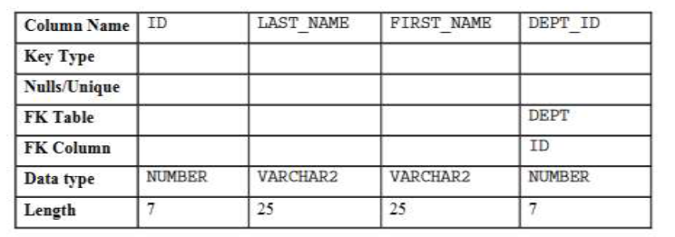

Write suitable query to perform following actions.(4 Marks)

• Modify the EMP table to allow for longer employee last names of size

as 50

• Confirm your modification.

|  |  |
| --- | --- |
| Give all the correct query options from the list below  a. create table EMPLOYEES(empno number,name varchar2(50) not null,job varchar2(50),manager number, hiredate date,salary number(7,2),commission number(7,2),deptno number,constraint pk_employees primary key (empno),constraint fk_employees_deptno foreign key (deptno) references DEPARTMENTS (deptno));  b. create table EMPLOYEES(empno numbers,name varchar2(50) not null,job varchar2(50),manager numbers, hiredate date,salary numbers(7,2),commission numbers(7,2),deptno numbers,constraint pk_employees primary key (empno),constraint fk_employees_deptno foreign key (deptno) references DEPARTMENTS (deptno));  c. create table EMPLOYEE(empno number,name varchar2(50) not null,job varchar2(50),manager number, hiredate date,salary number(7,2),commission number(7,2),deptno number,constraint pk_employees primary key (empno),constraint fk_employees_deptno foreign key (deptno) references DEPARTMENTS (deptno));  d. insert into EMPLOYEES (empno, name, job, salary, deptno) values (4101,'Sam Smith','Programmer',5000,4001 );  e. insert into EMPLOYEES (empno, name, job, salary, deptno) values (4101,Sam Smith,Programmer,5000,4001 );  f. create table student(ID char(4) primary key,Fname varchar2(10),deptID char(4));  g. create table student(ID char(4),Fname varchar2(10),deptID char(4),constraint primary key (ID),foreign key (deptID) references dept(deptID));  h. select dept_no,max(salary) from employess GROUP BY dept_no HAVING max(salary)>10000;  i. select deptno,max(salary) from employess GROUP BY deptno HAVING max(salary)>10000; | CO2 |

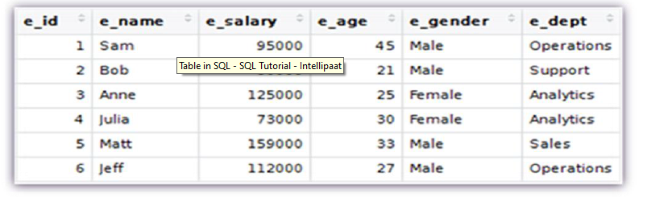

List of queries are

• INSERT

• CREATE

• ALTER

• DELETE

• REMOVE

• UPDATE

• DROP

Give the answers for the below given functions

a. ROUND(56.678,2)

b. MOD(3401,100)

c. FLOOR(2.83)

Write a join query to create a view with the below attributes and table names as given below.

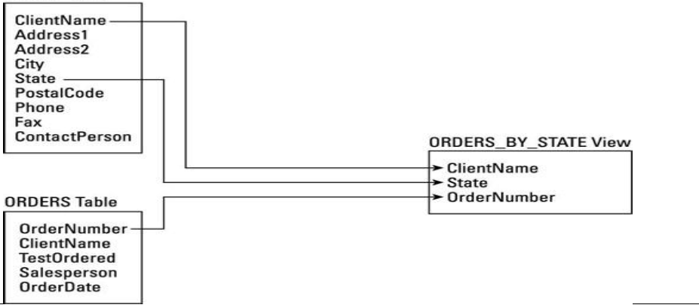

|  |  |
| --- | --- |
| Write the correct create table queries with the below given constraints to create the student and course table. Also specify the insert query to add the below given data into the tables. Consider suitable datatypes. | CO2 |

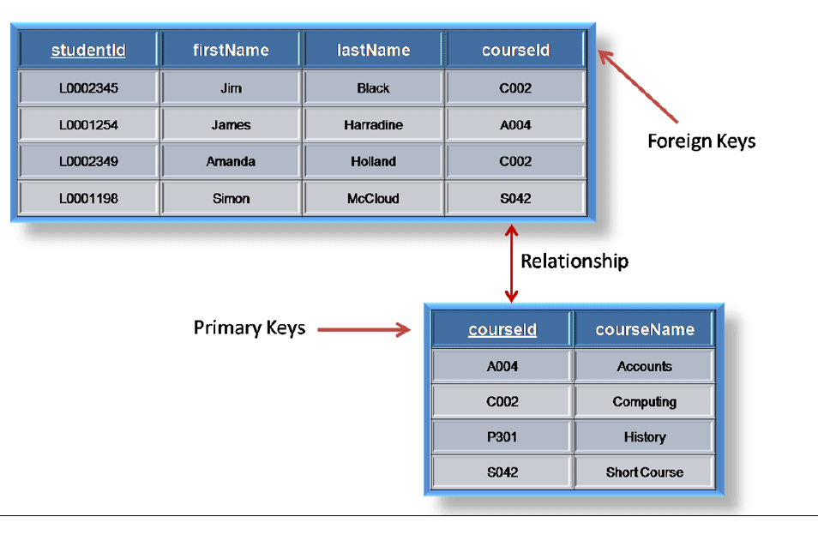

|  |  |
| --- | --- |
| Consider the below given table Employee to answer the below questions.    1. Find the highest, lowest, sum, and average salary of all employees. Label the columns Maximum, Minimum, Sum, and Average, respectively. Round your results to the nearest whole number.  2. Find the difference between the highest and lowest salaries.  3. Find the count of employees in the organization.  4. Find the count of employees working in each department.  5. Modify the query to display the minimum, maximum, sum, and average salary for each job type. | CO3 |

1. Explain normalization in the context of SQL databases.

[5, C01]

2. Make use of your knowledge on SQL and outline the difference between the INNER JOIN and

OUTER JOIN.

Case Study

A medium sized Company deals with industrial applications of computers. The Company delivers various products to its customers ranging from a single application program through to complete installation of hardware with customized software. The Company employs various experts, consultants and supporting staff. All personnel are employed on long-term basis, i.e. there is no short-term or temporary staff. Although the Company is somehow structured for administrative purposes (that is, it is divided into departments headed by department managers) all projects are carried out in an inter-disciplinary way. For each project a project team is selected, grouping employees from different departments, and a Project Manager (also an employee of the Company) is appointed who is entirely and exclusively responsible for the control of the project, quite independently of the Company's hierarchy.

Q3. Discover Discover

various types of data that need to be used in the system? Also give the format of the file structures for the same.

[10, CO3]

Q4. Discuss the changes that you will have to incorporate each time a new functionality is to be added to the system?